**CAN/CGSB-12.1-202X**

**Textile test methods**

**Textiles — Tear properties of fabrics —**

**Part 1: Determination of tear force using ballistic**

**pendulum method (Elmendorf)**

**(ISO 13937-1:2000, IDT)**

**Supersedes CAN/CGSB-12.1-2022**

**Safety glazing**

ICS 81.040.20

Document type: National Standard of Canada

Document stage:   **40 – Public review**

|  |
| --- |
| **Warning**  This document is not an approved standard. It is a draft distributed to CGSB committee members and other interested persons for review and comment. This draft is subject to change without notice and must not be referred to as a CGSB Standard.  Recipients of this document are invited to submit their comments, to advise the CGSB committee of any relevant patent rights that they are aware of, and to provide supporting documentation. This information should be provided on or before 2025-02-03, to:  Sohaila Moghadam  Canadian General Standards Board  L’Esplanade Laurier  140 O’Connor Street  Tower East, 6th floor  Ottawa, ON Canada K1A 0S5  [Sohaila.Moghadam@tpsgc-pwgsc.gc.ca](mailto:Sohaila.Moghadam@tpsgc-pwgsc.gc.ca) |

|  |
| --- |
| **Copyright notice**  ©HIS MAJESTY THE KING IN RIGHT OF CANADA, as represented by the Minister of Public Services and Procurement Canada, the Minister responsible for the Canadian General Standards Board, 2024.  This Canadian General Standards Board (CGSB) document is a draft standard. This document may be reproduced by CGSB committee members participating in its development, for purposes of this development only. No other reproduction, transmission, telecommunication or publication of whole or any part of this document may be undertaken without the prior written permission of CGSB.  Requests for permission to reproduce, transmit, communicate via telecommunication, publish or otherwise exploit the copyright in the whole or any part of this document should be addressed to CGSB at the address or co-ordinates shown below:  Manager, Standards Division  Canadian General Standards Board  140 O’Connor Street,  Tower East, 6th floor  Ottawa, ON Canada K1A 0S5  Telephone: 1-800-665-CGSB  Email: ncr.cgsb-ongc@tpsgc-pwgsc.gc.ca  Internet: https://www.tpsgc-pwgsc.gc.ca/ongc-cgsb/index-eng.html  Permission relating to the reproduction or publication of the whole or any part of this document may be made conditional upon the requester entering into a licensing agreement with CGSB. |

**CAN/CGSB-12.1-202X**

**Supersedes CAN/CGSB-12.1-2022**

Safety glazing

CETTE NORME NATIONALE DU CANADA EST DISPONIBLE EN VERSIONS

FRANÇAISE ET ANGLAISE.

ICS 81.040.20

Published Month Year by the

Canadian General Standards Board

Ottawa, Ontario K1A 0S5

© HIS MAJESTY THE KING IN RIGHT OF CANADA,

as represented by the Minister of Public Services and Procurement Canada,

the Minister responsible for the Canadian General Standards Board (202X).

No part of this publication may be reproduced in any form without the prior permission of the publisher.

Canadian General Standards Board

Committee on Glass

(Voting membership at date of Public Review)

**Chair**

Margaret Webb Consultant (General)

**General interest category**

Alex Hayes National Research Council Canada

Courtney Calahoo R&D Associate Glass Division

Doug Perovic University of Toronto

George Torok Morrison Hershfield Limited

Mathieu Audet Association de vitrerie et de fenestration du Québec (AVFQ)

Terry Adamson Fenestration Canada

**Producer category**

Amy Roberts Fenestration and Glazing Industry Alliance (FGIA)

Julia Schimmelpenningh Eastman Chemical Company

Kyle Cartwright Westeck Windows and Doors

Michael Liversidge Precision Glass Services Inc.

Ray Wakefield Trulite Glass and Aluminum Solutions Canada ULC

Thomas Zaremba Alliance of Primary Fire Rated Glazing Manufacturers

Tyler Zinck Vitro Architectural Glass Canada Inc.

**Regulator category**

Mike Hill Government of Alberta – Municipal Affairs

Nicholas Shipley Health Canada

**User category**

Andrew Crosby Read Jones Christoffersen Ltd.

Brent Harder Ferguson Corporation

Brian Peters Salient Engineering

David Vadocz RDH Building Science Inc.

Jack Mantyla Canadian Home Builders’ Association

Mark Brook BVDA Façade Engineering Inc.

Simone Panziera Thinkform Architecture + Interiors

**Committee manager (non-voting)**

Sohaila Moghadam Canadian General Standards Board

Translation of this National Standard of Canada was conducted by the Government of Canada

**Preface**

This National Standard of Canada CAN/CGSB-12.1-20XX supersedes the 2022 edition.

**Changes since the previous edition**

- Expanded classifications to include a section on vacuum insulating glass (VIG).

- Various editorial fixes related to the CGSB Style Manual.

- Sections on testing method description were replaced with references to the appropriate ASTM standard to better harmonize with ANSI Z97.1 *Safety Glazing Materials Used in Buildings – Safety Performance Specifications and Methods of Test*.

- Normative references were updated and bibliography was added.

- Annex B was added to consider the climate resiliency on glass when exposed to extreme conditions and related to climate change.

The following definitions apply in understanding how to implement this National Standard of Canada:

• "shall" indicates a **requirement**;

• "should" indicates a **recommendation**;

• "may" is used to indicate that something is **permitted**;

• "can" is used to indicate that something is **possible**, for example, that an organization is able to do something.

Notes accompanying clauses do not include requirements or alternative requirements. The purpose of a note accompanying a clause is to separate explanatory or informative material from the text. Annexes are designated normative (mandatory) or informative (non-mandatory) to define their application.

**Table of contents Page**

1 Scope 1

2 Normative references 1

3 Terms and definitions 2

4 Classification 4

5 General requirements 5

6 Detailed requirements 5

7 Packaging, packing, labelling and marking 7

8 Inspection 8

9 Sampling 8

10 Testing 8

Annex A (informative) Areas of human impact 28

Annex B (informative) Climate Resiliency 29

Bibliography 33

**Figures**

**Figure 1 ─ Impact test structure 1****0**

**Figure 2 ─ Impactor bag 1****0**

**Figure 3 ─ Impact test frame ─ Front view 1****1**

**Figure 4 ─ Detail of section A-A properly clamped test specimen [> 3 mm (1/8 in.)] 1****2**

**Figure 5 ─ Detail of section A-A improperly clamped test specimen [>3 mm (1/8 in.)] 1****2**

**Figure 6 ─ Impact test frame – Side view 1****3**

**Figure 7 ─ Impact test frame – Bent glazing – Front view 1****4**

**Figure 8 ─ Detail of section B-B 1****5**

**Figure 9 ─ Detail of section C-C 1****5**

**Figure 10 – Detail of section D-D 1****6**

**Figure 11 ─ Bent glass impact test frame (Exploded view) 1****6**

**Figure 12 ─ Impact test frame ─ Bent glazing ─ Side view 1****7**

**Figure 13 ─ Impactor** **19**

**Figure 14 ─ Centre punch fragmentation 2****3**

**Tables**

**Table 1 ─ Grouping of tests for different glazing materials 9**

**Table 2 ─ Applicable interpretation of results for shot bag impact 2****1**

**Table B.1 ─ Climate Resiliency Potential Impacts** **30**

**Introduction**

Past editions of CAN/CGSB-12.1 were specific to tempered and laminated safety glass. The objectives of the CGSB Committee on Glass with the 202X edition are to:

a) clearly define safety glass and its product categories;

b) harmonize as much as possible with the American National Standard Institute document ANSI Z97.1 *Safety Glazing Materials Used in Buildings – Safety Performance Specifications and Methods of Test*;

c) update the standard to address technologies and products introduced into the market;

d) ensure that this standard is applicable to Canadian building practices and compliant with the National Building Code of Canada; and

e) to address climate resiliency and the potential for the use of safety glazing products in more applications due to extreme weather events.

To facilitate the above objectives, the CGSB Committee on Glass had representation from all the safety glazing product manufacturing sectors, representatives from the ANSI Z97.1 committee, as well as representation from other sectors to ensure the required committee balance.

There are third party testing and certification programs that verify compliance to the standard[1]. Manufacturers may find it beneficial to obtain a certification through one of these available programs.

Canada has been experiencing the effects of climate change which have impacted the various regions and ecosystems including increased wildfires, flooding, increased winds and other extreme events. It is recommended that users of this standard review conditions for their environment as there may be a need for additional uses of safety glazing. For additional guidance on climate resiliency, refer to Annex B.

The scope, application and labelling requirements of CAN/CGSB-12.1 and ANSI Z97.1 continue to be harmonized, including product categories and tests.

Acknowledgment is extended to the members of the ANSI Z97.1 committee for working so closely with the CGSB Committee on Glass. Their assistance in providing access to the ANSI Z97.1 standard and any background information needed was essential to the development of this standard.

**Safety glazing**

# 1 Scope

This National Standard of Canada applies to glazing materials that have been subjected to the test methods described herein. Such test methods are intended to demonstrate minimum performance characteristics designed to reduce the likelihood of cutting and piercing injuries resulting when glazing materials used in areas of human impact (see Annex A) in building and architectural applications are broken by human impact.

This standard does not address the strength, durability, fire rated characteristics, appearance or methods of installation for glazing materials.

The following are not considered safety-glazing materials under this standard: monolithic annealed glass, monolithic heat-strengthened glass, monolithic glass-ceramic and monolithic wired glass.

The testing and evaluation of a product against this standard may require the use of materials and/or equipment that could be hazardous. This document does not purport to address all the safety aspects associated with its use. Anyone using this standard has the responsibility to consult the appropriate authorities and to establish appropriate health and safety practices in conjunction with any applicable regulatory requirements prior to its use.

Units of measurement – Quantities and dimensions used in this standard are provided in units from the International System of Units (imperial equivalents may be shown in brackets).

# 2 Normative references

The following normative documents contain provisions that, through reference in this text, constitute provisions of this National Standard of Canada. The referenced documents may be obtained from the sources noted below.

Note: The contact information provided below was valid at the date of publication of this standard.

An undated reference is to the latest edition or revision of the reference or document in question, unless otherwise specified by the authority applying this standard. A dated reference is to the specified revision or edition of the reference or document in question.

## 2.1 American National Standards Institute (ANSI)

ANSI Z97.1 ─ *Safety Glazing Materials Used in Buildings ─ Safety Performance Specifications and Methods of Test*

### 2.1.1 Contact information

The above may be obtained from the Copyright Accredited Standards Committee (ASC) Z97. Telephone: 785‑271‑0208. Web site: [Homepage | ASC Z97](https://www.ansiz97.com/).

## 2.2 ASTM International

ASTM C1036 — *Standard Specification for Flat Glass*

ASTM C1349 — *Standard Specification for Architectural Flat Glass Clad Polycarbonate*

ASTM C1503 — *Standard Specification for Silvered Flat Glass Mirror*

*ASTM C1900 – Standard Practice for Weathering and Evaluation of Laminated Glass*

*ASTM C1914 - Standard Test Method for Bake and Boil Testing of Laminated Glass*

ASTM D785 — *Standard Test Method for Rockwell Hardness of Plastics and Electrical Insulating Materials*

ASTM D790 — *Standard Test Methods for Flexural Properties of Unreinforced and Reinforced Plastics and Electrical Insulating Materials*

ASTM D1003 — *Standard Test Method for Haze and Luminous Transmittance of Transparent Plastics*

ASTM D2240 — *Standard Test Method for Rubber Property − Durometer Hardness*

ASTM D2244 — *Standard Practice for Calculation of Color Tolerances and Color Differences from instrumentally Measured Color Coordinates*

ASTM D6110 — *Standard Test Method for Determining the Charpy Impact Resistance of Notched Specimens of Plastics*

ASTM E308 — *Standard Practice for Computing the Colors of Objects by Using the CIE System*

ASTM E313 — *Standard Practice for Calculating Yellowness and Whiteness Indices from Instrumentally Measured Color Coordinates*

ASTM E903 - *Standard Test Method for Solar Absorptance, Reflectance, and Transmittance of Materials Using Integrating Spheres*

### 2.2.1 Contact information

The above may be obtained from ASTM International. Telephone: 610-832-9585. Web site: [www.astm.org](http://www.astm.org). They can also be obtained from Standards Store by Accuris. Telephone: 613-237-4250 or 1-800-267-8220. Web site: <https://global.ihs.com>.

# 3 Terms and definitions

For the purposes of this National Standard of Canada, the following terms and definitions apply.

**2-ply glass laminates**

laminated glazing consisting of two sheets of glass bonded together with an interlayer.

**asymmetric material**

glazing in which component layers of its construction makeup are different in thickness, kind, type or pattern texture about its interlayer or film and/or central plane surface.

**bent glass**

flat glass that has been shaped while hot into a form that has curved surfaces.

**bubble**

visible gas pocket in the interlayer material or in the plastic glazing sheet material, or between the interlayer and another layer of glass or plastic glazing sheet material.

**cracking**

visible breaking, splitting or fissuring, either partially or completely through the thickness of an individual layer of material.

**crack-free particle**

portion of a broken test specimen that is determined by identifying the smallest possible perimeter around all points in the portion of the broken test specimen, always passing along un-separated cracks or exposed surfaces.

**crazing**

visible breaking, splitting or fissuring of a material, typically patterned with a network of fine lines that do not penetrate through the thickness of an individual layer of material.

**delamination**

condition in which one of the glass or plastic glazing sheet material layers loses its bond to an interlayer and separates physically.

**discoloration**

noticeable chemical or process induced colour deviation in the appearance of a material that is visible to the unaided or corrected eye.

**tempered glass**

glass of any shape that has been subjected to a thermal treatment process characterized by uniform heating followed by rapid uniform cooling to produce compressively stressed surface layers.

Note: For the purposes of this standard, tempered glass refers to fully tempered glass pursuant to ASTM C1048 for additional requirement information. See 4.2 for further information.

**glass/plastic laminates**

laminated glazing consisting of one or more layers of glass and one or more layers of plastic glazing sheet material bonded together with one or more interlayer(s) in which the plastic surface faces inward or toward an insulating cavity, when the glazing is installed in a structure.

**laminated glazing**

manufactured assembly consisting of at least one sheet of glass or glass-ceramic bonded to at least one other sheet of glass, glass-ceramic or plastic glazing material with an organic interlayer.

Note 1: For plastics laminated to plastics, see plastic glazing material.

Note 2: When broken, numerous cracks appear, but glass fragments tend to adhere to the interlayer. See ASTM C1172 for additional information.

**mirror glazing**

architectural glazing materials whose intended use is based on their reflective quality. These materials are composed of a reflective surface and may have a substrate of glass, or plastic.

**multi-ply glass laminates**

laminated glazing consisting of more than two layers of glass and/or plastic glazing sheet material bonded together by interlayers, where both of the outer surfaces are glass.

**organic coated glass**

assembly consisting of a sheet of glass covered on one or both surfaces with either: 1) an adhesive‑applied organic film or sheeting, or 2) an applied coating. When broken, numerous cracks appear, but the glass fragments tend to adhere to the applied organic material.

**plastic glazing material**

single sheet of synthetic plastic material, a combination of two or more such sheets laminated together, or a combination of plastic material and reinforcement material in the form of fibres or flakes. This material contains, as an essential ingredient, an organic substance of large molecular weight; is solid in its finished state; and, at some stage in its manufacture or in its processing into finished articles, can be shaped by flow. See ASTM C1349 for additional information.

**safety glazing materials**

glazing materials so constructed, treated, or combined with other materials that, if broken by human contact, the likelihood of cutting or piercing injuries that might result from such contact is reduced.

**vacuum insulating glazing (VIG)**

An insulating glazing composed of two glass lites, hermetically sealed at the edges, with a vacuum between to virtually eliminate convection and conduction across the cavity. An array of small standoffs (commonly referred to as “pillars”) are placed throughout the cavity to keep the lites from touching.

# 4 Classification

## 4.1 Laminated glazings

Glazing assemblies consisting of one or more sheets of glazings and/or plastic glazing material bonded together with one or more organic interlayers. Laminated glazings can include 2-ply laminates, multi-ply laminates and glass/plastic laminates. When broken, numerous cracks may appear, but glass fragments may adhere to the interlayer(s).

Note: For additional information, see ASTM C1172.

### 4.2 Fully tempered glazings

Glass lites that have been thermally treated in a manufacturing process of uniform heating followed by rapid uniform cooling that produces compressively stressed surface layers in the glass. When broken, the entire lite cracks immediately into very small, granular pieces. Fully tempered glass is also known as toughened glass.

Note: For additional information, see ASTM C1048.

### 4.3 Organic-coated glazings

Glazing assemblies consisting of a lite of glass covered on one or both surfaces with either: 1) an adhesive-applied organic film or sheeting, or 2) an applied organic coating. When broken, numerous cracks appear, but the glass fragments may adhere to the organic coating. Examples of glazings that can be organically coated include wire glass, glass-ceramic, annealed glass, fully tempered glass, chemically strengthened glass, heat strengthened glass and mirror glazings.

### 4.4 Plastic glazings

A single sheet of synthetic plastic material, a combination of two or more such sheets laminated together, or a combination of plastic material and reinforcement material in the form of fibres or flakes. This material contains as an essential ingredient an organic substance of large molecular weight; is solid in its finished state; and, at some stage in its manufacture or in its processing into finished articles, can be shaped by flow.

Note: For additional information, see ASTM C1349.

### 4.5 Mirror glazings

Glazing materials are used architecturally for their reflective qualities. Mirror glazings have a reflective surface and a substrate of glass or plastic.

Note: For additional information, see ASTM C1503.

**4.6 Vacuum insulating glass**

Vacuum insulating glass (VIG) is typically two or more planar glass lites, with each lite of glass separated from the other by a distance typically less than one millimetre. VIG has an array of pillars or spacers to maintain the void between the lites of glass and a hermetic edge seal – typically a glass frit, which joins together and encircles the entire perimeter of the VIG unit. Often a getter material is employed to control residual gas build up ;

A hermetically sealable portal, or pump out tube, through which to evacuate residual gas.

# 5 General requirements

## 5.1 Tests shall be applied to specimens as shipped by the manufacturer and shall be representative of commercial production, except that any protective masking material shall be removed prior to the test.

## 5.2 The thickness of the specimens to be tested shall be measured and recorded along with the nominal thickness. No manufacturer shall mark or advertise as passing the tests described in this standard, any product of different nominal thickness than that of the specimens passing the tests.

# 6 Detailed requirements

## 6.1 Specimen size classification

A description of the required size classifications for impact testing are set forth below.

### 6.1.1 Unlimited size (U)

863 mm x 1930 mm, ± 3 mm (34 in. x 76 in., ± 1/8 in.).

### 6.1.2 Limited size (L)

Appropriate to manufacturer, largest size commercially produced by the manufacturer less than 864 mm x 1930 mm, ± 3 mm (34 in. x 76 in., ± 1/8 in.). Minimum specimen size: 406 mm x 762 mm, ± 3 mm (16 in. x 30 in., ± 1/8 in.).

No manufacturer submitting specimens that are in the limited size classification shall mark or advertise as passing the tests described in this standard, any product with either dimension greater than those of the specimens that have passed the tests.

## 6.2 Specimens for impact tests

### 6.2.1 Safety glazing material

a) Any applications

For impact test (see 10.1) of any safety glazing material, four specimens, each of the thickness and size described in 5.2. and 6.1 respectively, are required. If the test specimens are of an asymmetric material, two shall be impacted from each side.

Note: Testing of alternate shapes and sizes other than those specified in 6.2 does not qualify the product for unlimited use.

b) Indoor applications

For impact test after aging (see 10.4.2) of safety glazing materials used in indoor applications, four specimens, each of the thickness and size described in 5.2 and 6.1 respectively, are required. If the test specimens are of an asymmetric material two shall be impacted from each side.

### 6.2.2 Mirror glazing with organic adhesive backing material

For mirror glazing using either reinforced or non-reinforced organic adhesive backing material, four specimens each with the backing material applied, of the thickness and size described in 5.2 and 6.1 respectively, are required. The specimens shall be impacted only on the non-reinforced side and with no other material applied.

### 6.2.3 Bent glass

Bent glass test methods shall be the same as for flat sample testing except as referenced in the text and figures of this standard (see figures 7, 8, 9, 10, 11 and 12). For unlimited size (U) classification of bent glass, 864 mm x 1930 mm (34 in. x 76 in.) specimens with a simple arc-shaped bend of 1016 mm (40 in.) shall be tested. Interpretation of results shall be the same.

Note 1: See ASTM C1464 for additional information.

Note 2: Where project-specific requirements or limitations in production exist, other shapes and sizes may be tested*.*

## 6.3 Specimens for thermal test

For thermal test (see 10.3), three specimens, each 310 mm x 310 mm (12 in. x 12 in.), representative of commercial production and of identical manufacture and nominal thickness as submitted for impact testing (see 6.2), are required.

## 6.4 Specimens for weathering tests

For weathering tests (see 10.4), specimens as described in 6.4.1 and 6.4.2, representative of commercial production and of the thinnest construction for which qualification is desired, are required. Specimens constructed of laminated glass, organic-coated glazings or plastics, that have decorative or other functional materials inserted or embedded within the glazing material, shall not need to undergo weathering and subsequent testing if all of the following criteria are met:

a) the interlayer, organic coating or plastic material encapsulates the decorative or otherwise functional material;

b) the interlayer, organic coating or plastic is deemed to comply with 10.4;

c) the thickness of the interlayer, organic coating or plastic on each side of the insert or embedded material is at least the minimum thickness as qualified in 10.4.

The use of an insert or embedded material does not preclude the requirements for impact testing.

### 6.4.1 Plastic glazing material

One unbacked panel, a minimum of 152 mm x 152 mm (6 in. x 6 in.), shall be exposed. One additional unbacked panel, a minimum of 152 mm x 152 mm (6 in. x 6 in.), shall be kept in darkness and used as a control.

A minimum of five specimens, each 12.7 mm x 127 mm (1/2 in. x 5 in.), is necessary for the Charpy Impact Test (ASTM D6110). Alternate panel sizes may be used provided that enough material exists to cut a total of five specimens after exposure. Edges shall be trimmed from exposed panels prior to cutting specimens to minimize edge effects. For materials suspected of being anisotropic, the direction of one axis shall be marked on each panel, and all specimens shall be cut in the same direction.

### 6.4.2 Laminated glazing and organic coated glazing

Six specimens, each a minimum of 51 mm x 152 mm (2 in. x 6 in.) shall be prepared. Three specimens shall be exposed and three shall be kept in darkness and used as controls. Optical measurements for visible light transmittance, yellowness, haze and colour may be taken on an unexposed sample designated for exposure to serve as the unexposed control values.

### 6.4.3 Mirror glazing

Mirror glazing shall not be used for external glazing without passing all requirements for organic coated glass.

## 6.5 Specimens for modulus and hardness tests

### 6.5.1 Specimens for flexural modulus

The specimen dimensions are dependent on the thickness of the material and the span distance capabilities of the testing machine. The dimensions shall meet the requirements of ASTM D790 for flatwise tests.

### 6.5.2 Specimens for Rockwell hardness

The specimens shall be at least 25 mm (1 in.) square and at least 6 mm (1/4 in.) thick. Materials less than 6 mm (1/4 in.) thick may be stacked provided that the precautions noted in ASTM D785 are met.

Note: For common plastic glazing thickness and common testing machine capabilities, specimens 12.7 mm (1/2 in.) wide and 127 mm (5 in.) long can meet the requirements. Decreased width and/or increased length may be needed in some cases to meet the span to depth ratio, span to width ratio and span to length requirements of the standard.

# 7 Packaging, packing, labelling and marking

After having successfully met the requirements of this standard, like products of the same nominal thickness produced in the same manner as the specimens which conform, shall be legibly and permanently marked.

## 7.1 Marking information

### 7.1.1 Content of the mark

The mark shall contain the following information:

a) supplier's name, distinctive mark or designation;

b) standard designation: CAN/CGSB-12.1-20XX;

c) classification of test size (L or U) and drop height class (A or B). Plastic glazing does not require drop height;

d) place of fabrication (if fabricator has more than one location fabricating the product).

Note: Additional details and information, such as thickness and date of manufacture, are permitted.

#### 7.1.2 Example of the mark

Individual layout of the mark may vary based on the manufacturer and the product, and are deemed acceptable upon meeting the requirements in 7.1.

**Basic Basic with some optional information**

Glazing company A Glazing company B

CAN/CGSB-12.1-2022 LA INT[2]2 Laminated (optional)

Plant ID (if more than one location) CAN/CGSB-12.1-2022 LA INT

Plant ID (if more than one location)

YYYYMMDD (Date code optional)

## 7.2 Application of the mark

The appropriate party using the following guidelines shall apply the permanent mark.

a) Laminated glass stock sheets (i.e., size produced by the manufacturer) shall be marked by the manufacturer of the stock sheet.

b) All glazing products including cut size laminates, fully tempered glass, and organic coated glazing shall be marked by the company producing the finished cut to size glass product.

c) The fabricator or manufacturer shall mark plastic glazing materials.

d) The installer of the safety film shall mark field-applied organic coatings (films).

## 7.3 Special application marking

Certain types of glazing material shall also be marked with additional information as appropriate.

### 7.3.1 Safety glazing materials used in indoor applications only

After having successfully passed the appropriate tests (see 10.4.2, like products and materials produced in the same manner as specimens submitted for testing shall be legibly and permanently marked with the words “Indoor Use Only/Utiliser à l’intérieur seulement”.

### 7.3.2 Organic coated glass only

Organic coated glazing materials shall be legibly and permanently marked with the words “Glaze This Side In/ Placer cette face vers l’intérieur” to indicate to the installer, inspector, or user which side of the organic coated glass should be exposed to the elements if there is a specific side that should be exposed.

# 8 Inspection

Upon inspection, product marked in compliance with this standard shall have passed the requirements of section 10.

# 9 Sampling

Sampling shall be as required by the inspection authority.

# 10 Testing

A summary of test types and groups for different glazing materials is provided in Table 1.

Table 1 ─ Grouping of tests for different glazing materials

|  |  |  |  |  |  |
| --- | --- | --- | --- | --- | --- |
| **Tests** | **Glazing materialsa** | | | | |
| **Laminated glazings** | **Fully tempered glass** | **Organic coated glazings** | **Plastic glazing** | **VIGb** |
| Impact (see 10.1) | **X** | **X** | **X** | **X** | **X** |
| Centre punch fragmentation (see 10.2) | **─** | **Xc** | **─** | **─** |  |
| Thermal (see 10.3) | **X** | **─** | **Xd** | **-** | **X** |
| Weathering**e**(see 10.4) | **X** | **─** | **Xf** | **X** | **X** |
| Indoor aging (see 10.4.2) | **X** | **─** | **X** | **X** |  |
| Hardness (see 6.5 and 10.1.4.3) | **─** | **─** | **─** | **Xg** |  |
| Modulus (see 6.5 and 10.1.4.3) | **─** | **─** | **─** | **Xg** |  |
| a Bent and mirror glazing shall be tested in accordance with requirements of the base-glazing product (see 6.2).  b VIG can meet Type (1) or (4) if laminated and Type (2) or (4) if fully tempered.  c Centre punch fragmentation test is used to evaluate the fracture pattern of fully tempered glass specimens that do not break during impact test of 10.1.  d Thermal test only applies to organic coated glazings when organic coated glazings are used in the building envelope.  e Weathering tests on laminated and organic coated glasses shall be performed on the thinnest construction of all components with clear glass, clear plastics and clear interlayers.  f Mirror glazing shall be tested in accordance with 10.4.2  g Only required if breakage occurs under impact. | | | | | |

## 

## 10.1 Impact test

Required specimens shall be tested as submitted except that any protective masking or protective material shall be removed prior to the test. Any applied coating integral to the specimens shall not be removed. The specimens shall be conditioned to a uniform test temperature between 18 °C and 29 °C (65 °F and 85 °F) for at least 4 h with separation to permit free air circulation.

### 10.1.1 Apparatus

The test apparatus shall consist of a test frame and an impactor system. The test frame consists of a main frame mounted on two base beams with stiffening members and a sub-frame, in which the specimen is held. The impactor system consists of the impactor, traction, release, and suspension devices.

#### 10.1.1.1 Main frame

The main frame shall be constructed to minimize movement, deflection, twisting or racking of its members during testing. For this purpose, the structural framing members shall be steel angles 76 mm x 127 mm x 6 mm (3 in. x 5 in. x 1/4 in.) or other sections and materials of equal or greater rigidity. The main frame shall be welded or securely bolted at the corners and braced as shown infigures 1, 3 and 6.

The main frame is mounted to a rigid floor and/or wall. Horizontal members made of steel sections connect the main frame to a rigid wall. The base beams are connected to the main frame by diagonal members of steel sections (see figures 1, 3 and 6). Attach the two base beams of the main frame to a concrete base or floor using bolts M16 or equivalent.

Internal dimensions of the main frame (figure 3) shall be: internal width: 845 mm ± 5 mm (33.25 in. ± 1/5 in.), internal height: 1911 mm ± 5 mm (75.25 in. ± 1/5 in.).

The internal dimensions of the main frame shall be 19 mm (3/4 in.) less than unlimited size [864 mm x 1930 mm (34 in. x 76 in.)] specimen dimensions.

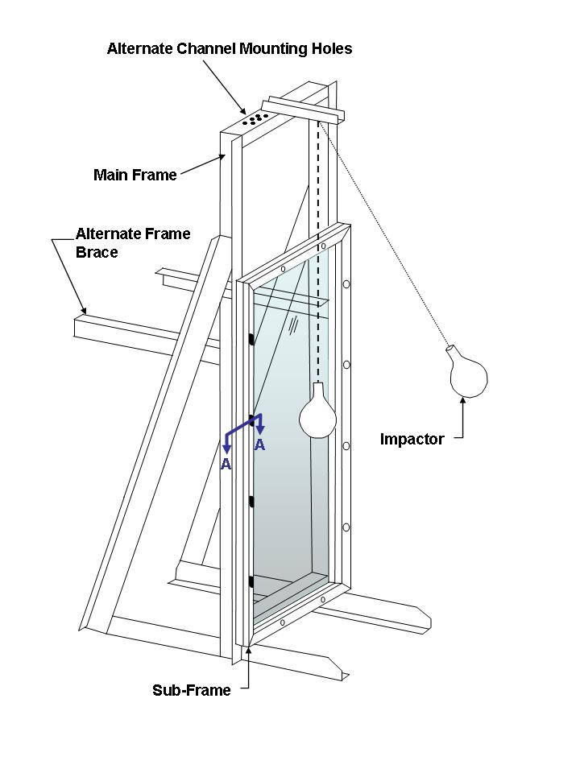

Figure 1 ─ Impact test structure



Figure 2 ─ Impactor bag



Swivel attachment located at vertical centre line of test specimen and 1524 mm (60 in.) minimum above horizontal centre line.

845 mm (33 1/4 in.)

Height of test specimen minus 19 mm (3/4 in.)

1911 mm (75 1/4 in.)

Width of test specimen minus 19 mm (3/4 in.)

Alternate sub-frame members for testing specimens smaller than 864 mm x 1930 mm (34 in. x 76 in.).

This portion of the test frame not required if swivel attachment is mounted on separate construction.

Figure 3 ─ Impact test frame ─ Front view



Steel angle, L127 mm x 76 mm x 6 mm thick

(L5 in. x 3 in. x 1/4 in.)

19 mm (3/4 in.) minimum

38 mm (1 1/2 in.) minimum

10 mm x 19 mm (3/8 in. x 3/4 in.) neoprene strips durometer hardness: 30–50 Shore “A”

Test specimen

Outer sub-frame

51 mm

(2 in.) minimum

Inner sub-frame

Metal shims to provide no more than 15% rubber compression (based on thickness of glass).

Figure 4 ─ Detail of section A-A properly clamped test specimen [> 3 mm (1/8 in.)]



Test specimen

127 mm (5 in.)

Figure 5 ─ Detail of section A-A improperly clamped test specimen [>3 mm (1/8 in.)]



No more than 51 mm (2 in.) when bag is hanging free

Alternate means of bracing test frame: use one brace at each vertical member.

Stranded steel cable approximately 3 mm (1/8 in.) diameter

1524 mm (60 in.) minimum

Bolt securely to floor

1524 mm (60 in.) minimum

914 mm (36 in.) minimum

Centre line of test specimen

Test specimen

Drop

height

914 mm (36 in.) minimum

Bridle for lifting impactor

Concrete wall steel beam or other sturdy construction

Figure 6 ─ Impact test frame – Side view

Swivel attachment located at vertical centre line of test specimen and 1524 mm (60 in.) minimum above horizontal centre line.



Dimension to match width of test specimen minus 19 mm (3/4 in.), for example: a 864 mm x 1930 mm (34 in. x 76 in.) specimen with a 1016 mm (40 in.) radius bend would have a chord length of 836 mm (32.9 in.), therefore 836 mm – 19 mm = 817 mm (32.9 in. – 0.75 in. = 32.15 in.).

Alternate sub-frame members for testing specimens smaller than 864 mm x 1930 mm

(34 in. x 76 in.).

845 mm (33 1/4 in.)

Height of test specimen minus 19 mm (3/4 in.)

1911 mm (75 1/4 in.)

Width of test specimen minus 19 mm (3/4 in.)

This portion of the test frame not required if swivel attachment is mounted on separate construction.

Note: Outer sub-frame not shown.

Figure 7 ─ Impact test frame – Bent glazing – Front view



Steel angle, L127 mm x 76 mm x 6 mm thick (L5 in. x 3 in. x 1/4 in.)

19 mm (3/4 in.) minimum

127 mm (5 in.)

Outer sub-frame

Test specimen

10 mm x 19 mm (3/8 in. x 3/4 in.) neoprene strips durometer hardness:

30–50 Shore “A”

52 mm

(2 in.) minimum

38 mm (1 1/2 in.) minimum

Inner sub-frame

Figure 8 ─ Detail of section B-B

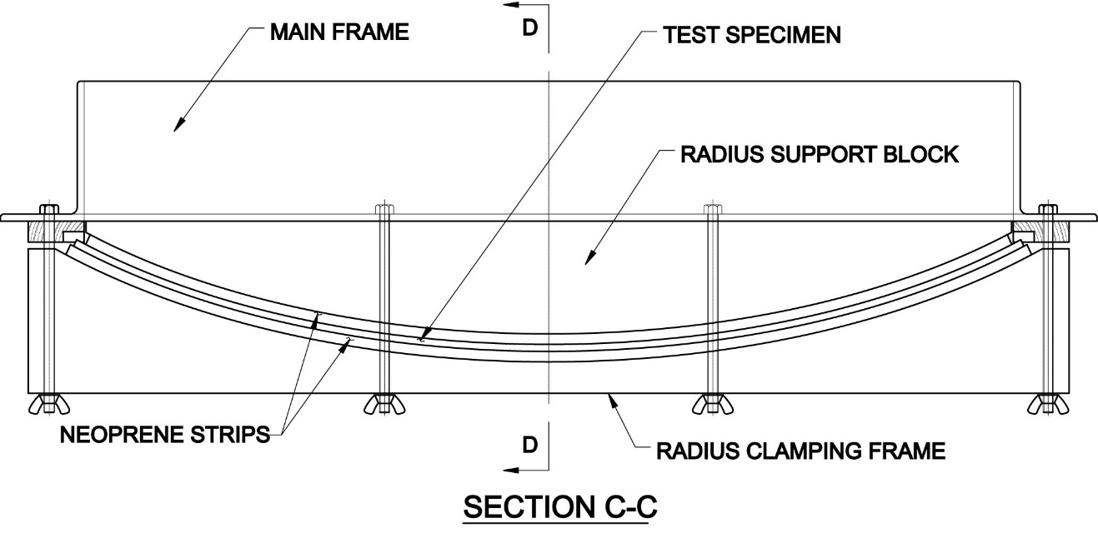

Figure 9 ─ Detail of section C-C

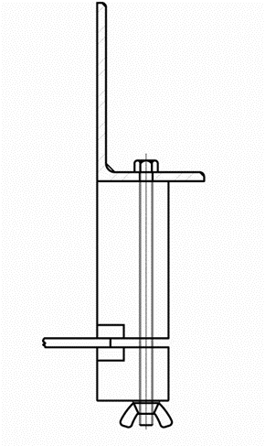

Figure 10 – Detail of section D-D

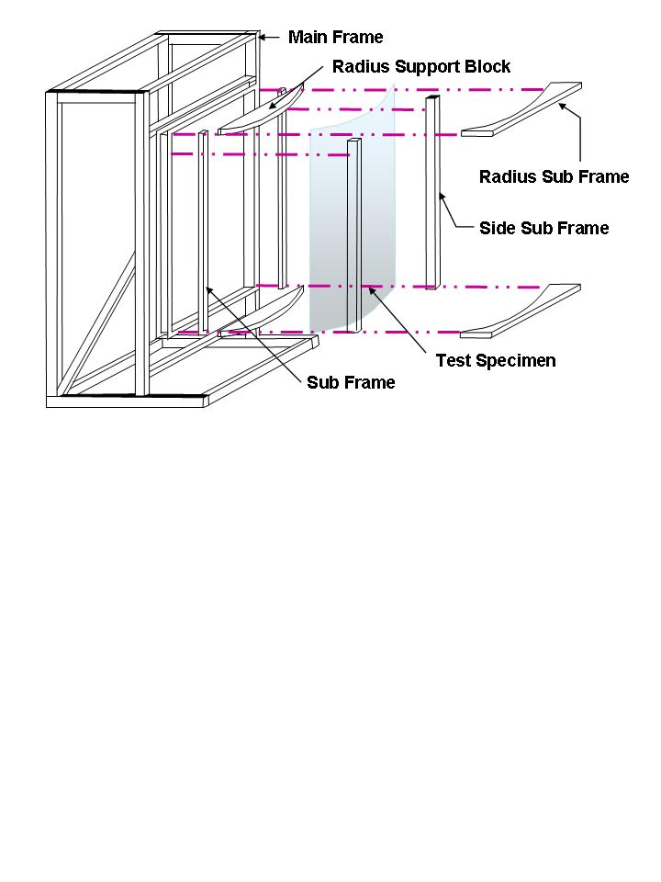

Figure 11 ─ Bent glass impact test frame (Exploded view)



Alternate means of bracing test frame: use one brace at each vertical member.

No more than 51 mm (2 in.) when bag is hanging free

1524 mm (60 in.) minimum

Bolt securely to floor

1524 mm (60 in.) minimum

914 mm (36 in.) minimum

Stranded steel cable approximately 3 mm (1/8 in.) diameter

Centre line of test specimen

Test specimen

Concrete wall steel beam or other sturdy construction

Bridle for lifting impactor

914 mm (36 in.) minimum

Drop

height

Figure 12 ─ Impact test frame ─ Bent glazing ─ Side view

#### 10.1.1.2 Sub-frame (Test specimen mounting frame) (see figures 4 and 5)

The sub-frame for securing the specimens on all four edges consists of two parts made from wood or other material, which is hard enough to withstand the pressure exerted by the clamping forces. Each part shall be provided with a groove or rebate in which a strip of elastomeric rubber is laid; the specimen shall only contact the elastomeric rubber strips.

The inner sub-frame (see figures 4 and 5), which is in contact with the specimen, is 51 mm x 19 mm (2 in. x 3/4 in.) minimum. The outer part of the sub-frame holds the specimen and is 50 mm x 38 mm (2 in. x 1.5 in.) minimum.

The sub-frame is fixed to the main frame by at least twelve bolts (M10 bolts, scissors clamps or equivalent). These shall be fixed at the points marked on figure1 and figure3, with no fewer than two on any edge and spaced no more than 450 mm (18 in.) apart.

To provide and limit elastomeric rubber compression and avoid sub-frame distortion, non-compressible shims appropriate to glazing thickness shall be used to separate the inner and outer parts of the sub-frame (see figure4).

The elastomeric rubber strip, the only element of the sub-frame that the test specimen shall come into contact with, shall be 19 mm (3/4 in.) wide by 10 mm (3/8 in.) thick and have a Shore-A hardness of 40 ± 10 (see ASTM D2240).

Note: Modifications that clearly do not alter the function or performance of the mainframe or sub-frame are acceptable. Any reasonable means may be used to secure the sub-frame to the main frame provided the mounting is secure and the pressure on the glazing specimen in the sub-frame is controlled.

#### 10.1.1.3 Impactor

The impactor shall consist of the leather bag described in figures 2 and 13, a commercial punching bag with its bladder left in place, or any other leather bag of nominally identical shape and size. The bag shall be filled with lead shot of 2.4 mm ± 0.1 mm diameter (nominal USA No. 7 1/2 or European No. 7 lead shot) and taped. After filling with lead shot, the top shall be either pulled over the metal sleeve and tied with a cord; or twisted around the threaded eyebolt shaft and tied below the metal sleeve, or both. To reduce bag damage during testing, the exterior of the leather bag surface shall be completely covered with glass filament reinforced pressure sensitive polyester adhesive tape[3]3, 12 mm to 15 mm (1/2 in. to 3/5 in.) in width and 0.15 mm (0.006 in.) thick. Tape the entire bag, using three rolls or 165 m (180 yd.) total length, and taping in a diagonal-overlapping manner. Tape the neck of the bag separately, with additional glass filament reinforced tape of the same kind. The total mass of the impactor assembly shall be 45.4 kg ± 0.2 kg (100 lb. ± 4 oz.) as described in figure13, excluding traction system attachments.

To reduce bag deformation during testing, the bag shall be rotated about the axis of its suspension device before each specimen or sample set, by no less than 30 degrees, and by no more than 90 degrees.

Note: To reduce bag damage during testing, a thin homogeneous or nonwoven plastic film no more than 0.13 mm (0.005 in.) thick or a loosely draped woven cloth towel weighing no more than 0.05 g/cm2 (0.0113 oz./in2) may be suspended vertically in front of the surface of the specimen at a distance no more than 10 mm (2/5 in.).

The impactor shape shall be maintained constant during testing. To reduce visible deformation of the impactor, it shall be removed from the suspension device and pummelled with a rubber mallet into its approximate original shape.



Tape neck separately.

Remove hanging strap.

Steel washers

5 mm ± 2 mm (3/16 in. ± 1/16 in.)

330 mm ± 25 mm

(13 in. ± 1 in.)

Fill bag with lead shot so that total weight of assembly is 45 kg ± 2 kg (100 lb ± 4 oz.).

76 mm

± 3 mm

(3 in. ± 1/8 in.)

Eye nut for lifting bridle (see Figure 6)

3 mm (1/8 in.) radius on washer edge to prevent tearing

Cover entire surface of bag with 12 mm (1/2 in.) wide glass filament reinforced pressure-sensitive tape.

6 mm (1/4 in.) or larger threaded steel rod

32 mm x 25 mm long (1 1/4 in. x 1 in.) diameter steel sleeve (series of steel washers may be used)

Worm-drive hose clamp, install before bag is taped

Threaded eye or swivel fitting

Figure 13 ─ Impactor

#### 10.1.1.4 Suspension device

The impactor is suspended by means of a single, stranded-steel cable, approximately 3 mm (1/8 in.) diameter, from an upper swivel fixture above the head of the main frame at an elevation of which the minimum distance between the swivel-fixture and impactor centre line is 1524 mm (60 in.).The upper swivel fixture shall be rigid to ensure the point of suspension remains stationary. The lower swivel(s) or equivalent shall be provided on the bag for rotation of the impactor about its suspension device axes between impact events.

When at rest, the surface of the impactor, at its maximum diameter, shall be located no more than 51 mm (2 in.) from the surface of the specimen and no more than 51 mm (2 in.) from the centre of the specimen.

#### 10.1.1.5 Traction and release system

A traction system shall be used which enables the impactor to be brought into its launch position. The launch position depends on the drop height selected. The traction cable is connected to the impactor traction system by a release mechanism, with provisions for rotating the impactor.

To position the impactor at the selected drop height, a traction force shall be applied to raise the impactor such that the axis of the impactor shall be aligned with the suspension cable, with the cable remaining taut. To ensure this, the top and bottom ends of the impactor shall be connected to the release device by a suitable link.

### 10.1.2 Impact classification

Glazing materials shall be submitted for impact testing to a selected drop height class.

#### 10.1.2.1 Drop height class

Glazing materials conforming to this standard are classified by their performance under the impact test at the selected drop height.

a) Class A **─** glazing material that complies with the requirements of 10.1.4 when tested in accordance with the procedure in 10.1.3 at a drop height between 1219 mm and 1232 mm (48 in. and 48 ½ in.) using an impact specimen appropriate to the size classification.

b) Class B ─ glazing material that complies with the requirements of 10.1.4 when tested in accordance with the procedure in 10.1.3 at a drop height of between 457 mm and 470 mm (18 in. and 18 ½ in.) using an impact specimen appropriate to the size classification.

#### 10.1.2.2 Drop height qualification

Glazing material qualified for classification at the higher impact drop height level Class A, shall be deemed to comply with the lower-impact drop height level Class B.

### 10.1.3 Impact procedure

a) Place and centre each specimen in the sub-frame so each edge is encased in the elastomeric rubber strip to a depth of at least 10 mm (2/5 in.). With the specimen mounted, the elastomeric rubber strip shall not be compressed by more than 15% of its thickness. For bolts, torque shall be 20 Nm + 5 Nm (15 ft‑lb + 4 ft-lb).

Note: For vacuum insulating glass (VIG), mark a border of 25 mm (1 inch) around the entire perimeter of the test specimen (see section 10.2). Marking this area with a dark marker is suggested.

b) Select a drop height classification from 10.1.2.1. Rotate the impactor as required. Raise the impactor to the selected drop height intended for classification and stabilize it. At the selected drop height, the suspension device shall be taut and the axes of the impactor and cable shall be in line.

c) The impactor, stabilized in the launch position in a vertical plane normal to the test specimen, is released and falls without initial velocity or axial rotation. At least one impact shall occur on each test specimen. Unbroken specimens may be reused for higher classification impact testing.

d) Classify the test specimen in accordance with the glazing in Table 2. Inspect each test specimen after impact and record and report whether it complied or did not comply with the applicable interpretation of results contained in Table 2. If classified as fully tempered glass, open the sub-frame to allow any particles to be released and fall free.

e) When testing VIG and composite perimeter fragments are observed, first an effort shall be made to separate any crack-free particles suspected of being in the “10 largest” search. If this is not possible, then crack-free fragments in the perimeter area shall be physically geometrically measured for area and that measured area, with calculations, added to the selected 10 largest crack-free particles to determine if the test specimen complied or did not comply. As an alternate to physical area measurement, some form of digital photography and/or calculation method is acceptable.

f) If any of the required specimens fail to comply with the requirements of 10.1.4, the material shall not be classified for impact.

g) For asymmetric materials, the test shall be carried out on both sides using equal numbers of separate specimens.

h) When the required number of specimens is impacted and inspected, report the impact classification as described in 10.1.2. If all specimens tested by impact either do not break, or break according to the requirements of 10.1.4, the glazing material shall be classified as described in 10.1.2, at the impact level tested. Classification shall comprise the word “Class”, followed by a letter designation (A or B) for drop height class (see 10.1.2.1).

i) If it is required to test the material to a higher impact classification level, repeat the test on the required number of undamaged specimens of the same material at the higher impact level. At the fabricator’s discretion, previously tested but unbroken specimens may be used for higher impact classification testing.

j) Each specimen of bent glass will be impacted on the convex surface at the centre of the specimen perpendicular to the frame from the selected drop height (see figures7 and 9).

Note : The convex surface is tested due to the realistic constraints of the test set up in impacting the concave surface. Additionally, as of the date of this publication, no data was available that showed one surface is more or less likely to break during impact.

Table 2 ─ Applicable interpretation of results for shot bag impact

|  |  |  |  |  |  |
| --- | --- | --- | --- | --- | --- |
| **Interpretation of results** | **Laminated glazing** | **Fully tempered glass** | **Organic coated glazings** | **Plastic glazing** | **VIGa** |
| Type (1) | **X** | **─** | **X** | **─** | **X** |
| Type (2) | **─** | **X** | **─** | **─** | **X** |
| Type (3) | **─** | **─** | **─** | **X** | **─** |
| Type (4) | **X** | **X** | **X** | **X** | **X** |
| a VIG can meet Type (1) or (4) if laminated and Type (2) or (4) if fully tempered. | | | | | |

### 10.1.4 Acceptance criteria

Evaluation after impact shall occur whether the specimen remains fully engaged in the frame or partially engaged in the frame, or is entirely disengaged from the frame. A glazing material shall be judged to pass the impact test if any one of the applicable acceptance criteria below is met by each of the required number of impact specimens tested.

#### 10.1.4.1 Type (1)

Upon impact, one or more cracks may appear. Fragments tend to be contained by the interlayer or adhesive‑like laminated or organic-coated glazing.

**Specimen acceptance criteria**: No tear or shear or opening develops within the vertical specimen through which a 76 mm (3.0 in.) diameter sphere can pass using a horizontally applied force of 18 N (4.0 lb.) or less. Additionally, if particles are detached from the test specimen (including particles that might be retained in the frame under the stops), up to 3 min after impact, they shall, in total, weigh no more than a mass equivalent to 10 000 mm2 (15.5 in.2) of the original test piece. The largest single particle shall weigh less than a mass equivalent to 4400 mm2 (6.82 in.2) of the original test piece. Detached individual particles less than the mass equivalent of 650 mm2 (1 in.2) shall be excluded from the fragment analysis.

#### 10.1.4.2 Type (2)

Upon impact, the specimen shatters like fully tempered glass.

**Specimen acceptance criteria**: The ten largest crack-free particles shall be selected within 5 min subsequent to the impact and shall weigh no more than the equivalent weight of 6452 mm2 (10 in.2) of the original specimen. For purposes of impact test acceptance when breakage occurs, the average thickness of a fully tempered glass specimen containing grooves, bevels, or other thickness altering fabrication shall be considered the average of the thinnest measurement of each of the ten geometrically largest crack-free particles. This average thickness will then be used to determine the maximum allowable weight of the ten largest crack-free particles.

Note: For soda lime glass, the weight in ounces of 6452 mm2 (10 in.2) is equal to 14.5 times the glass thickness in inches. The weight in grams of 6452 mm2 (10 in.2) of glass is equal to 412 times the glass thickness in inches (16.18 g/mm).

#### 10.1.4.3 Type (3)

Upon impact, the specimen breaks like plastic glazing.

**Specimen acceptance criteria**: The stiffness and hardness of the specimen shall be determined. A modulus of elasticity (see ASTM D790) less than 3.9 GPa (550 000 psi) and a Rockwell hardness (see ASTM D785) less than M or R 140 shall indicate satisfactory compliance.

#### 10.1.4.4 Type (4)

Upon impact, the specimen does not break.

**Specimen acceptance criteria**: No breakage occurs. For fully tempered glass, the specimen shall meet 10.2.

## 10.2 Centre punch fragmentation test

This test is only used to evaluate glass specimens that do not break during the impact test of 10.1.

This test is to be performed in addition to the test described in 10.1. Specimens for testing shall have been previously tested per 10.1. Specimens temperature shall be between 18.3 °C and 29.4 °C (65 °F and 85 °F) prior to testing.

### 10.2.1 Equipment

The following equipment is required:

a) a **sharp impactor** such as a pointed hammer of about 75 g (2.65 oz.) mass, or a spring-loaded centre punch or similar appliance can be used;

b) a **means of specimen support** consisting of a flat base with adjustable horizontal curbs to prevent scattering of fragments;

c) a **calibrated scale** suitable for accurately weighing selected particles to the nearest 0.1 g (0.004 oz.);

d) a **calibrated micrometre** capable of measuring the thickness of the selected specimen/particle.

### 10.2.2 Procedure

a) Flat glass: Place the specimen on the flat base and place the curb lightly along the specimen edges so the sample can elongate slightly yet the fragments remain interlocked.

b) Bent glass: Place the specimen on the bent glass impactor frame on a flat base with the convex side facing up. The specimen shall have edges continuously supported.

c) Strike the test specimen 25 mm (1 in.) inboard of the longest edge at its midpoint until fracture occurs.

### 10.2.3 Weight determination

Within 5 min after fracture, collect and weigh the ten largest crack-free pieces. In the event any of the ten largest pieces crack after original selection, all pieces shall be weighed.

For transparent flat glass, measure the thickness of the largest piece. For patterned glass thickness measurement, see ASTM C1036 for thickness measurement technique. Record the thickness.

Note: Some applications may require a particle count in accordance with BS EN 12150[4]4.

### 10.2.4 Centre punch fragmentation interpretation of results

The total weight of the ten largest crack-free pieces shall weigh no more than the equivalent weight of 6452 mm2 (10 in.2) of the original test sample.

Note: For soda lime glass, the weight in ounces of 6452 mm2 (10 in.2) is equal to 14.5 times the glass thickness in inches. The weight in grams of 6452 mm2 (10 in.2) of glass is equal to 412 times the glass thickness in inches (16.18 g/mm).

No one particle shall be longer than 102 mm (4 in.) excluding an area of radius 102 mm (4 in.) centred on the impact point, and a border of 25 mm (1 in.) around the entire perimeter/edge of the test specimen (see figure 14).

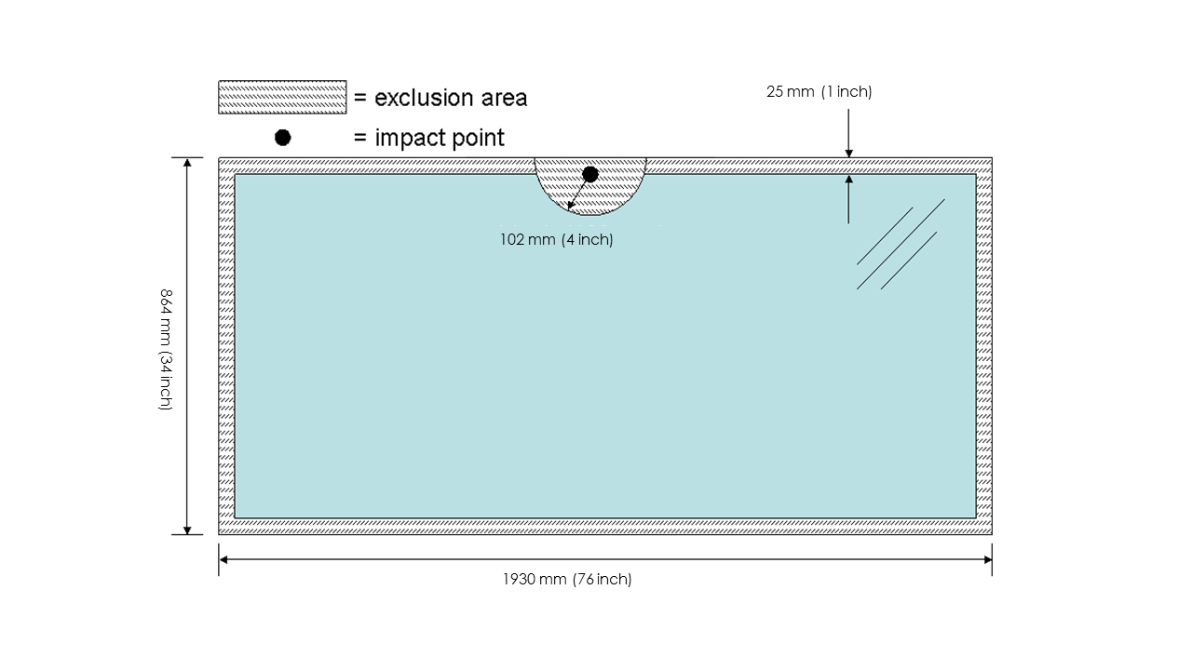Figure 14 ─ Centre punch fragmentation

If any of the required specimens fail to comply with the requirements of 10.2.4, the material shall not be classified for impact.

## 10.3 Thermal test for laminated and organic coated glazings

This test shall be made to determine the probable effect of exposure to high temperature and humidity conditions for a long period of time.

### 10.3.1 Procedure

Three 305 mm x 305 mm (12 in. x 12 in.) flat specimens, as submitted, shall be subjected to an extended heat history through bake testing in an oven or boil testing in accordance with ASTM C1914. The thermal test may be conducted either in a heating chamber, boiling water or both. Thermal test only applies to organic coated glazings that are used for exterior glazing.

### 10.3.2 Acceptance criteria

The specimen is evaluated in accordance with ASTM C1914.

## 10.4 Weathering tests for laminated, organic coated and plastic glazings

The purpose of these tests is to determine whether these safety-glazing materials will successfully retain their safety characteristics after exposure to weathering conditions for an extended period of time. This is determined through the measurement of laminated properties known to indicate stability of commonly used polymers in safety glazing. The weathering methods described in ASTM C1900 shall be used for all materials subjected to exterior or interior exposure. After weathering, organic-coated glass shall be tested as described in 10.4.1.1 and 10.4.1.2; laminates shall be tested as described in 10.4.1.1 and 10.4.1.3, and plastics shall be tested as described in 10.4.1.4. Plastic, organic coated or laminated materials intended for interior use only shall be subjected only to the aging requirements in 10.4.2.

### 10.4.1 Tests after weathering

Specimens exposed in accordance with 10.4 shall be tested after weathering according to the procedures outlined in 10.4.1.1 to 10.4.1.4. For organic coated glass, see 10.4.1.1 and 10.4.1.2; for laminates, see 10.4.1.1 and 10.4.1.3; and for plastics, see 10.4.1.4.

#### 10.4.1.1 Laminated and organic coated materials

Assessment of optical changes after weathering are included for laminated and organic coated materials as significant changes can be indicative of product degradation which may have an effect on impact and safety performance. Changes in the blank glazing (see 10.4.1.3) based on the comparison of non-weathered retain data shall be deducted from the weathered laminated or organic coated specimens for evaluation of the properties listed in 10.4.1.2.

Acceptance criteria: When compared to control (unexposed) samples, no weathered specimen shall exhibit more than the allowable change, as specified, for the following properties:

1)visible light transmittancechange not greater than 5 percentage units (e.g.: 91% control ± 5% = 96% or 86%) as measured in accordance with ASTM D1003 or ASTM E903;

2)yellowness index (YI), for clear products only, increase not greater than 0.5 YI units (e.g., 0.70 YI control + 0.5 = 1.20) as measured in accordance with ASTM E313;

3)haze increase not greater than 0.5 percentage units (e.g., 0.70 control ± 1.20) as measured in accordance with ASTM D1003;

4)delta E less than or equal to 5 units as measured in accordance with ASTM E308, and calculated in accordance with ASTM D2244 and section 6.2.1.

#### 10.4.1.2 Organic coated glazing only

Organic coated glazing specimens shall be judged satisfactory if they pass the requirements of 10.4.1.1, adhesion test (see 10.4.1.2.1) and the tensile strength test (see 10.4.1.2.2).

##### 10.4.1.2.1 Adhesion test

a) Specimens: Six specimens, [nominally 51 mm x 152 mm (2 in. x 6 in.)] prepared as described in 6.4.2 shall be tested. The specimens shall be conditioned just prior to the performance of the adhesion test at 23 ºC ± 2 ºC (73.5 ºF ± 3.5 ºF) and 50% ± 2% relative humidity for 24 h.

b) Apparatus: The test apparatus shall be 1) a tensile tester of the constant-rate-of-extension (CRE) type with the moving crosshead set to move at 305 mm (12 in.) per minute and the load range set so that the average peel force will fall at 30%-50% of full scale, and 2) a cutting device containing new razor blades for cutting 25 mm (1 in.) wide specimens (use each blade once only).

c) Procedure: Using the 25 mm (1 in.) razor cutting device, cut a straight strip of the organic coating in the lengthwise direction of the specimen. Peel back about 52 mm (2 in.) of one end of the 25 mm (1 in.) wide organic strip. Attach a strip of pressure-sensitive tape to the side of the organic strip opposite the adhesive to extend this free end to about 203 mm (8 in.) in length. Place the end of the glass panel from which the organic strip was removed in the lower clamp of the tensile tester and the free end of the tape in the upper clamp. Peel the remainder of the organic strip from the glazing mechanically and obtain a record of the peel value. Determine the average pull for each specimen from the chart record.

d) Acceptance criteria: The organic coated glass adhesions shall be judged satisfactory if the average adhesion value of the three exposed specimens is no less than 75% of the average adhesion value of the three control (unexposed) specimens.

##### 10.4.1.2.2 Tensile strength test

a) Specimens: The samples for this test are the same specimens used in the adhesion test [see 10.4.1.2.1 and conditioned as in 10.4.1.2.1 a)].

b) Apparatus: The test apparatus shall be 1) a CRE tensile tester set as follows: gage length – 52 mm (2 in.); crosshead speed – 52 mm (2 in.) per minute; load range – set full-scale load so that specimens will break at 30%-60% of full scale, and 2) a cutter containing new razor blades for cutting 12 mm (1/2 in.) wide specimens (use each blade once only).

c) Procedure: Using the 12 mm (0.5 in.) razor cutting device, cut a straight strip of the organic coating in the lengthwise direction of the glass sample for the full 152 mm (6 in.) length. Carefully peel this strip from the glass panel and test it for breaking strength in the tensile strength tester.

d) Acceptance criteria: The organic-coating tensile shall be judged satisfactory if the average tensile value of the three exposed specimens is no less than 75% of the average tensile value of the three control specimens.

#### 10.4.1.3 Laminated and organic glazing only

a) Specimens: After exposure, the test specimens may be cleaned, if necessary, using a procedure recommended by their manufacturer to remove any residues present.

b) Conditioning: Both the unexposed and exposed specimens shall be conditioned prior to examination or further testing for a minimum of 48 h at 22 °C to 24 °C (71 °F to 75 °F) and 50% ± 2% relative humidity.

c) Viewing: When irradiated and conditioned, the exposed specimens shall be examined and compared visually with the unexposed controls. Specimens shall be placed in a vertical position. The viewer shall look through the specimen using daylight without direct sunlight, or using a background light suitable for observing blemishes. View at 910 mm (36 in.).

d) Acceptance criteria: Any improvement in clarity or discolouration is acceptable. When examined after ultraviolet exposure, each exposed test specimen shall meet the criteria of 10.4.2.1 and be substantially free of noticeable decomposition as defined by absence of the following specific kinds of developed defects or blemishes, when observed by this inspection method in comparison to unexposed control specimen(s):

1) no bubbles or delamination shall be visible more than 10 mm (0.4 in.) from any outer edge of the specimen; and

2) no crazing or cracking is allowed;

3) if no noticeable decomposition and no other defects develop upon exposure, the glazing material shall be reported as visually acceptable. Otherwise, unacceptable glazing material shall be reported as visually blemished.

e) Interpretation of weathering results: When the thinnest construction of all components of laminated and organic coated glazings have passed the applicable weathering requirements and subsequent evaluation as stated in 10.4, thicker components and coloured components of the same material are deemed as qualified for weathering compliance.

#### 10.4.1.4 Plastics only

a) Specimens: shall be evaluated before and after exposure in accordance with ASTM D6110, Charpy Impact Test, Method B, with the following exceptions:

1) the specimens shall not be notched;

2) the specimens shall be tested with the exposed surface in tension;

3) the specimens shall be exposed and tested flatwise;

4) the span shall be reduced to 52 mm (2 in.) for thin material that may slip through the supports without breaking;

5) the average of four samples taken from the weathered specimens shall be reported. A fifth sample shall be retained unexposed as a control.

b) Acceptance criteria: Plastic materials shall be acceptable for use as safety glazing if the impact strength as measured by the Charpy Impact Test is not reduced by more than 25% as a result of the natural or accelerated exposure. No bubbles or other physical degradation shall develop in the exposed portion.

### 10.4.2 Indoor applications only ─ Aging tests for laminates, plastics and organic coated glazing, and mirror glazing

The purpose of these tests is to determine whether laminates, plastic, organic coated glazing and mirror glazing for indoor use only will successfully retain their safety characteristics after exposure to simulated aging conditions for an extended period of time. The specimens described in 6.2 for impact test after aging shall be used. Specimen size shall be in accordance with 6.1. Specimens passing the requirements of natural or accelerated exposure (see 10.4) and subsequent testing (see 10.4.1) are deemed qualified for indoor applications without further evaluation. Weathering shall be conducted in accordance with indoor application requirements of ASTM C1900.

Acceptance criteria:

1) Aging tests for plastics used in indoor applications only

After exposure in accordance with ASTM C1900, specimens passing the requirements in 10.4.1 are qualified for indoor applications.

2) Aging tests for laminates and organic coated glazing used in interior applications only

After exposure in accordance with ASTM C1900, specimens passing the requirements in 10.4.1.2 are qualified for indoor applications.

3) Aging tests for mirror glazing used in interior applications only

i) Apparatus: a conditioning chamber of sufficient size to hold up to 864 mm x 1930 mm (34 in. x 76 in.) panels vertically and capable of maintaining conditions of 60 ºC ± 3 ºC (140 ºF ± 5 ºF), 38 ºC ± 3 ºC (100 ºF ± 5 ºF) and 95% ± 5% relative humidity, and 18 ºC ± 3 ºC (0 ºF ± 5 ºF).

ii) Procedure: Place four of the organic coated glazing specimens positioned vertically and spaced at least 25 mm (1 in.) apart in the chamber. Raise the temperature to 60 °C ± 5 °C (140 °F ± 5 °F) within 3 h and maintain for 21 h. Change the chamber conditions to 38 ºC ± 3 ºC (100 °F ± 5 °F) and 95% ± 5% relative humidity in 3 h and maintain for 21 h. This represents one complete cycle. Expose the specimens to ten complete cycles. At the completion of the tenth cycle, change the chamber conditions to 18 ºC ± 3 ºC (0 °F ± 5 °F) in 3 h and maintain for 21 h. The fifth specimen shall be retained unexposed as a control for the effects of the exposure cycling. Upon completion of the required number of exposure cycles, all specimens shall be tested as described in 10.1.

4) Impact test after aging for mirror glazing

i) Apparatus: The apparatus described in 10.1.1 shall be used.

ii) Procedure: All the specimens exposed as described in 10.4.2 shall be conditioned as per 10.1 and evaluated by the procedure in 10.1.2.

iii) Acceptance criteria: The exposed specimens shall again satisfactorily complete the impact test in accordance with 10.1.3. Milkiness may develop but defects other than these shall be cause for rejection.

# Annex A (informative) Areas of human impact

**A.1 General**

Areas of human impact include, but may not be limited to, doors, glazed panels adjacent to doors, glazed exterior/interior passageway doors, storm (combination) doors, guards, patio doors, and shower and bathtub doors and their enclosures. See ANSI Z97.1 for further information.

Annex B  
(informative)  
Climate Resiliency

**1. Introduction**

The expectation is that in the coming decades, the climate of Canada will become warmer, with some locations experiencing higher wind speed, more intense and frequent rain events, and as a result heightened wind-driven rain loads. The ability of construction materials and built assemblies to continue to perform under changing environmental conditions is called ‘climate resiliency’.

Users of this standard should be aware that tests noted in the CAN/CGSB glass standards are made at specified conditions of temperature, relative humidity, etc.  In-service conditions may be different and could affect the performance of some glass, safety glazing, and insulating glass unit products. Currently, the differences between test and in-service conditions are not considered significant but this could change in the future as the climate changes.

The user should refer to local building codes to ensure compliance with local jurisdiction in selecting the appropriate product for their application based on current climatic design data. Users should also consult with manufacturers of glass products (for example, the manufacturer of an interlayer for laminated glass, or perimeter sealants for insulating glass units) to determine if in-service conditions that are different from test conditions should be taken into account during product selection. Technology is rapidly evolving in the glass industry with constant introduction of new products. Design tools are now available that allow the user to estimate future climatic design data which can be used to discuss with manufacturers future possible service conditions in order to select the appropriate product for the intended application.

Users of the CGSB glass standards should note that each standard has a limited scope. The test methods are intended to address specific performance aspects. For example, CAN/CGSB-12.1 *Safety Glazing* addresses reducing injury to a person impacting a safety glazing product. It does not directly address other performance aspects such as strength, fire rating or appearance. Climate change may create new performance needs not previously considered such as wind-borne debris impact or higher wind loads which may be addressed in whole or in part by other standards. In some cases, a desired performance aspect may not be addressed by an available standard in which case, the assistance of a design professional should be obtained.

**2. Guidance for Climate Resiliency**

What guidance can be offered to building designers, glass and glazing product manufacturers, and builders now, when revised climate data that takes into account projections of climate change is not yet fully available and continues to evolve? Construction of new buildings and renovation of existing buildings cannot be stopped. Based on the available research on this topic as described in this Annex, some recommendations for the selection and installation of fenestration products are provided in Table B.1.

**Table B.1**

**Climate Resiliency Potential Impacts**

| **Climate change effects** | **Effects on glass and glazing products** | **Recommendations for selection of products** |
| --- | --- | --- |
| Higher ambient annual and daily air temperatures and humidity | Higher temperatures, change in flexibility and stiffness | Select materials that are more dimensionally stable with temperature change (lower coefficient of thermal expansion) to control expansion and contraction, and flexibility or stiffness. Applies especially to glass and glazing products with plastic components — interlayers, vinyl, fibreglass, and composites spacers for insulating glass units — that are directly exposed to solar radiation. |
| Select products with enhanced elasticity and resistance to repeated movement cycles, and which maintain flexibility or stiffness at anticipated in-service temperatures. Applies to organic jointing and sealing products such as butyl rubbers, polyurethanes, and polysulphides in glass, laminated glass, and insulating glass units. |
| Accelerated aging due to more prolonged periods of higher temperature (especially when wet) and from exposure to higher levels of UV-B radiation | Select products of proven and heightened resistance to heat aging and UV radiation. Applies to insulating glass units with organic and polymer-based spacers and sealants and laminated glass with interlayers directly exposed to solar radiation. |
|  | Increased risk of fire exposure, especially at the wildland urban interface (WUI) | Select fire-rated products. Applies to glass, safety glazing, and insulating glass units in fenestration products. |
|  | Increased risk of thermal stress related breakage | Select heat treated glass, and where safety glazing is needed, fully tempered glass. Applies to glass and glazing exposed to solar radiation that simultaneously are affected by thermal bridging, such as in balcony guards, high thermal performance windows, doors, and skylights, and other fenestration assemblies. |
| Increase in freeze / thaw cycles | Increase in temperature fluctuations, including more frequent and extreme freeze-thaw cycles | Select products that are designed to allow drainage of water that penetrates into glazing cavities. Applies to exposed elements such as a balcony guards. |
| Increase in precipitation, including wind driven rain | Increase in wind-driven rain loads.  Higher average temperature and humidity within fenestration product frames and in installation openings, together with increased incidence of water in more prolonged contact with glass and glazing products | Select fenestration products that enhance drainage of water from surfaces and minimize the likelihood of the entry and retention of water in fenestration product frames. Applies to fenestration products of all types incorporating laminated glass with interlayers prone to delamination under moisture and fenestration products with insulating glass units. |
| Select materials that are more dimensionally stable when wetted and that have enhanced resistance to degradation from contact with warm liquid water (hydrolysis). Applies to laminated glass with interlayers prone to delamination under moisture and insulating glass units with organic perimeter sealants. |
| Select materials with enhanced resistance to corrosion, or take steps to reduce the likelihood of wetting of corrosion susceptible materials. Applies to insulating glass units with sputter-coated low-e coated glass. |
| Increased Wind Speed and Design Pressures | Increased magnitude and frequency of extreme wind events (windstorms, tornadoes, hurricanes, down drafts, derechos) | Select fenestration products that incorporate glass and glazing with greater resistance to higher design wind pressure and with resistance to wind borne debris where required. Refer to climatic data in latest building codes for changes in wind pressure that may require the use of safety glazing such as fully tempered and / or laminated glass. |
|  |  |

The identification of broad classes of materials that are at risk from climate change effects is not meant to indicate that products made from them should not be used. Instead, building owners, designer professionals, specifiers, and builders should use the recommendations as guidance to discuss with glazing material and product manufacturers how to create resiliency to climate change.

Further guidance and literature to address the following potential future consequences of climate change on safety glazing products:

1. ASTM E997-15(2021) *Standard Test Method for Evaluating Glass Breakage Probability Under the Influence of Uniform Static Loads by Proof Load Testing*
2. [CSA A440.6 (2020) *High exposure fenestration installatio*n (ansi.org)](https://webstore.ansi.org/standards/csa/csaa4402020?gad_source=1&gclid=EAIaIQobChMImq-a493ThAMVh1N_AB0g0ACrEAAYASAAEgKNvPD_BwE)
3. [CSA A440S1:19 (R2022) | Product | CSA Group](https://www.csagroup.org/store/product/2426984/)
4. [CSA A440.4 (2019) Window, door, and skylight installation (ansi.org)](https://webstore.ansi.org/standards/csa/csaa4402019?gad_source=1&gclid=EAIaIQobChMImsyVqd7ThAMVLnFMCh0lKQgMEAAYASAAEgJgi_D_BwE)
5. [CSA A440.2-19/CSA A440.3 (2019) -*Fenestration energy performance / User guide to CSA A440.2-14, Fenestration energy performance* (ansi.org)](https://webstore.ansi.org/standards/csa/csaa440192019?gad_source=1&gclid=EAIaIQobChMIqbj9uN7ThAMVUEh_AB3jIw3REAAYASAAEgK5IvD_BwE) ANNEX B
6. CSA S520:22 *Design and construction of low-rise residential and small buildings to resist high wind*
7. CSA S478:19 *Durability in buildings*
8. ISO 12543-4:2021 *Glass in building — Laminated glass and laminated safety glass — Part 4: Test methods for durability*
9. ISO 16932:2020 *Glass in building — Destructive-windstorm-resistant security glazing — Test and classification*
10. ISO/DIS 19916-1:2018 *Glass in building — Vacuum insulating glass — Part 1:  Basic specification of products and evaluation methods for thermal and sound  insulating performance*
11. ISO 19916-3:2021 *Glass in building — Vacuum insulating glass — Part 3: Test methods for evaluation of performance under temperature differences*
12. ISO 20492-1:2008 *Glass in buildings - Insulating glass — Part 1: Durability of edge seals by climate tests*
13. ASTM E1300 (2016) *Standard Practice for Determining Load Resistance of Glass in Building*
14. CNR-DT 210/2013 *Construction and Control of Buildings with Structural Elements*
15. European 3 part standard CEN/TD 19100:2021 *Design of glass structures*
16. Infrastructure Canada-Climate-Resilient Buildings and Core Public Infrastructure initiatives

Bibliography

ASTM C1048 — *Standard Specification for Heat-Strengthened and Fully Tempered Flat Glass.* Available from: [www.astm.org](http://www.astm.org)

ASTM C1172 — *Standard Specification for Laminated Architectural Flat Glass.* Available from: [www.astm.org](http://www.astm.org)

ASTM C1464 — *Standard Specification for Bent Glass.* Available from: [www.astm.org](http://www.astm.org)

BS EN 12150 – *Toughened Glass Certification*. Available from: [European and International standards online store](https://www.en-standard.eu/?gad_source=1&gclid=Cj0KCQiA0fu5BhDQARIsAMXUBOJgL8T4yfrOrRozRRZ8ntNaE8-ipAk9vQgaDtbWLofSfBs2CobnQNkaAqy5EALw_wcB)

1. At the time of publishing, available third-party testing and certification programs include the Safety Glazing Certification Council (SGCC) [www.sgcc.com](http://www.sgcc.com). Other similar, third-party programs may also be available. Safety Glazing product testing is offered by Intertek [www.intertek.com](http://www.intertek.com) and UL Solutions of Canada <https://canada.ul.com>.
2. 2 LA stands for Laminated and INT means Internal.
3.
4. 3 Such as 3M No. 898 (a trade name), or equal. As of the date of publication of this version, Everlast no longer supplies these bags. A source of supply is the Safety Glazing Certification Council (SGCC) at [www.sgcc.org](http://www.sgcc.org).4 The publication BS EN 12150 is available from <http://shop.bsigroup.com>.